training 1 epoch...

53.66374921798706 seconds used......

1 training finished! average train loss: 0.41531190245823807

evaluating...

Confusion matrix, without normalization

[[ 0 0 13]

[ 0 0 29]

[ 0 0 340]]

Normalized confusion matrix

[[0. 0. 1.]

[0. 0. 1.]

[0. 0. 1.]]

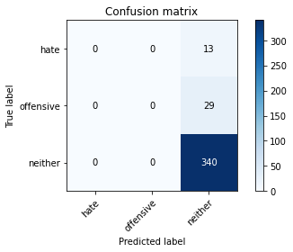

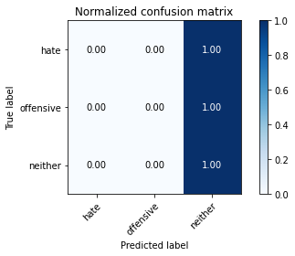

/usr/local/lib/python3.7/dist-packages/sklearn/metrics/_classification.py:1272: UndefinedMetricWarning: Precision and F-score are ill-defined and being set to 0.0 in labels with no predicted samples. Use `zero_division` parameter to control this behavior.

_warn_prf(average, modifier, msg_start, len(result))

precision recall f1-score support

hate 0.00 0.00 0.00 13

offensive 0.00 0.00 0.00 29

neither 0.89 1.00 0.94 340

accuracy 0.89 382

macro avg 0.30 0.33 0.31 382

weighted avg 0.79 0.89 0.84 382

average eval_loss: 0.36141286604106426, accuracy: 0.8900523560209425

training 2 epoch...

51.902801513671875 seconds used......

2 training finished! average train loss: 0.33578430798424536

evaluating...

Confusion matrix, without normalization

[[ 0 2 11]

[ 0 3 26]

[ 0 0 340]]

Normalized confusion matrix

[[0. 0.15384615 0.84615385]

[0. 0.10344828 0.89655172]

[0. 0. 1. ]]

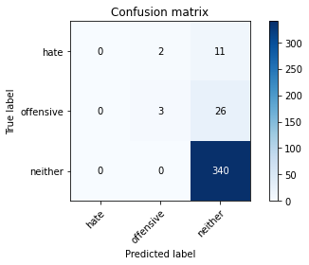

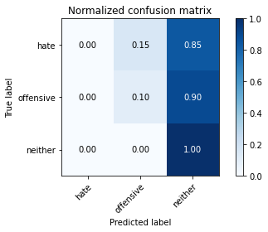

precision recall f1-score support

hate 0.00 0.00 0.00 13

offensive 0.60 0.10 0.18 29

neither 0.90 1.00 0.95 340

accuracy 0.90 382

macro avg 0.50 0.37 0.37 382

weighted avg 0.85 0.90 0.86 382

average eval_loss: 0.32033112542703746, accuracy: 0.8979057591623036

training 3 epoch...

51.97686171531677 seconds used......

3 training finished! average train loss: 0.21754082417397133

evaluating...

Confusion matrix, without normalization

[[ 0 2 11]

[ 0 1 28]

[ 0 1 339]]

Normalized confusion matrix

[[0. 0.15384615 0.84615385]

[0. 0.03448276 0.96551724]

[0. 0.00294118 0.99705882]]

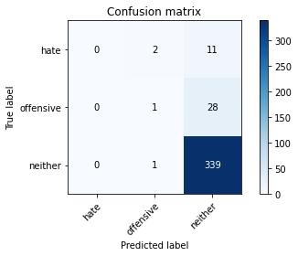

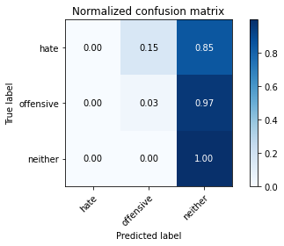

precision recall f1-score support

hate 0.00 0.00 0.00 13

offensive 0.25 0.03 0.06 29

neither 0.90 1.00 0.94 340

accuracy 0.89 382

macro avg 0.38 0.34 0.33 382

weighted avg 0.82 0.89 0.85 382

average eval_loss: 0.3786750629544258, accuracy: 0.8900523560209425

training 4 epoch...

52.233691930770874 seconds used......

4 training finished! average train loss: 0.09778759875172359

evaluating...

Confusion matrix, without normalization

[[ 0 3 10]

[ 1 5 23]

[ 1 5 334]]

Normalized confusion matrix

[[0. 0.23076923 0.76923077]

[0.03448276 0.17241379 0.79310345]

[0.00294118 0.01470588 0.98235294]]

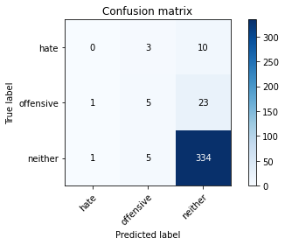

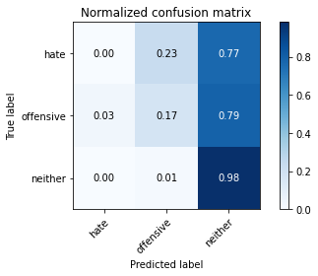

precision recall f1-score support

hate 0.00 0.00 0.00 13

offensive 0.38 0.17 0.24 29

neither 0.91 0.98 0.94 340

accuracy 0.89 382

macro avg 0.43 0.38 0.39 382

weighted avg 0.84 0.89 0.86 382

average eval_loss: 0.43449455313384533, accuracy: 0.887434554973822

training 5 epoch...

52.02318334579468 seconds used......

5 training finished! average train loss: 0.031016922005259996

evaluating...

Confusion matrix, without normalization

[[ 2 3 8]

[ 1 5 23]

[ 4 6 330]]

Normalized confusion matrix

[[0.15384615 0.23076923 0.61538462]

[0.03448276 0.17241379 0.79310345]

[0.01176471 0.01764706 0.97058824]]

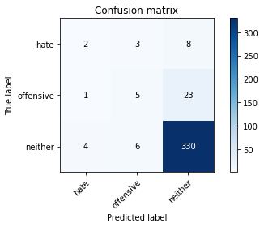

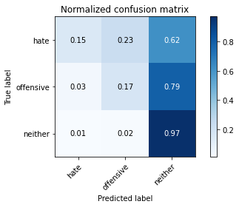

precision recall f1-score support

hate 0.29 0.15 0.20 13

offensive 0.36 0.17 0.23 29

neither 0.91 0.97 0.94 340

accuracy 0.88 382

macro avg 0.52 0.43 0.46 382

weighted avg 0.85 0.88 0.86 382

average eval_loss: 0.5113342417404055, accuracy: 0.8821989528795812

training 6 epoch...

52.19010281562805 seconds used......

6 training finished! average train loss: 0.010252504372295143

evaluating...

Confusion matrix, without normalization

[[ 0 4 9]

[ 1 5 23]

[ 3 6 331]]

Normalized confusion matrix

[[0. 0.30769231 0.69230769]

[0.03448276 0.17241379 0.79310345]

[0.00882353 0.01764706 0.97352941]]

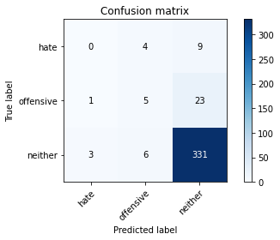

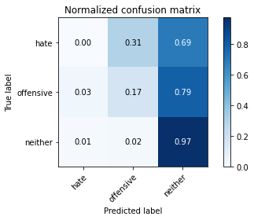

precision recall f1-score support

hate 0.00 0.00 0.00 13

offensive 0.33 0.17 0.23 29

neither 0.91 0.97 0.94 340

accuracy 0.88 382

macro avg 0.42 0.38 0.39 382

weighted avg 0.84 0.88 0.86 382

average eval_loss: 0.5898225153563544, accuracy: 0.8795811518324608

training 7 epoch...

52.265904903411865 seconds used......

7 training finished! average train loss: 0.01063296186340415

evaluating...

Confusion matrix, without normalization

[[ 1 4 8]

[ 0 4 25]

[ 0 5 335]]

Normalized confusion matrix

[[0.07692308 0.30769231 0.61538462]

[0. 0.13793103 0.86206897]

[0. 0.01470588 0.98529412]]

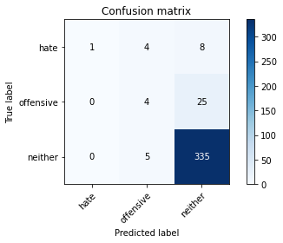

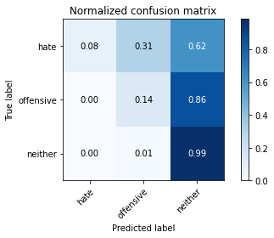

precision recall f1-score support

hate 1.00 0.08 0.14 13

offensive 0.31 0.14 0.19 29

neither 0.91 0.99 0.95 340

accuracy 0.89 382

macro avg 0.74 0.40 0.43 382

weighted avg 0.87 0.89 0.86 382

average eval_loss: 0.859916779352352, accuracy: 0.8900523560209425

training 8 epoch...

52.11975574493408 seconds used......

8 training finished! average train loss: 0.00849453094379833

evaluating...

Confusion matrix, without normalization

[[ 1 3 9]

[ 0 6 23]

[ 2 4 334]]

Normalized confusion matrix

[[0.07692308 0.23076923 0.69230769]

[0. 0.20689655 0.79310345]

[0.00588235 0.01176471 0.98235294]]

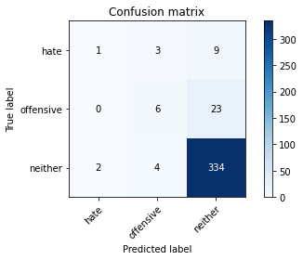

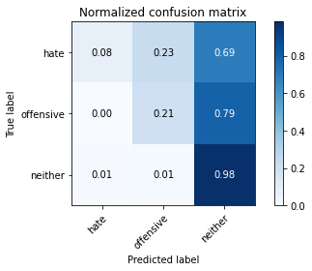

precision recall f1-score support

hate 0.33 0.08 0.12 13

offensive 0.46 0.21 0.29 29

neither 0.91 0.98 0.95 340

accuracy 0.89 382

macro avg 0.57 0.42 0.45 382

weighted avg 0.86 0.89 0.87 382

average eval_loss: 0.7864693060517312, accuracy: 0.8926701570680629

training 9 epoch...

52.27487659454346 seconds used......

9 training finished! average train loss: 0.0023644920375074942

evaluating...

Confusion matrix, without normalization

[[ 1 3 9]

[ 2 2 25]

[ 3 4 333]]

Normalized confusion matrix

[[0.07692308 0.23076923 0.69230769]

[0.06896552 0.06896552 0.86206897]

[0.00882353 0.01176471 0.97941176]]

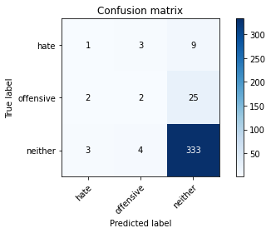

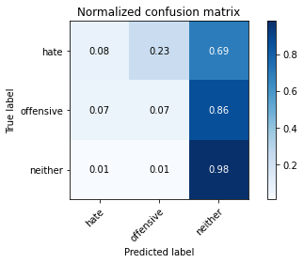

precision recall f1-score support

hate 0.17 0.08 0.11 13

offensive 0.22 0.07 0.11 29

neither 0.91 0.98 0.94 340

accuracy 0.88 382

macro avg 0.43 0.38 0.38 382

weighted avg 0.83 0.88 0.85 382

average eval_loss: 0.7179417027266026, accuracy: 0.8795811518324608

training 10 epoch...

52.12078237533569 seconds used......

10 training finished! average train loss: 0.0007840217967049982

evaluating...

Confusion matrix, without normalization

[[ 1 4 8]

[ 0 8 21]

[ 3 7 330]]

Normalized confusion matrix

[[0.07692308 0.30769231 0.61538462]

[0. 0.27586207 0.72413793]

[0.00882353 0.02058824 0.97058824]]

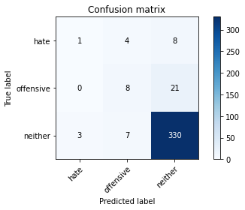

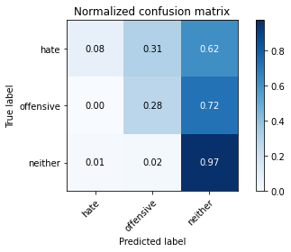

precision recall f1-score support

hate 0.25 0.08 0.12 13

offensive 0.42 0.28 0.33 29

neither 0.92 0.97 0.94 340

accuracy 0.89 382

macro avg 0.53 0.44 0.47 382

weighted avg 0.86 0.89 0.87 382

average eval_loss: 0.7245904205236912, accuracy: 0.887434554973822

model of 5 epoch

Confusion matrix, without normalization

[[ 2 2 37]

[ 4 9 82]

[ 6 18 690]]

Normalized confusion matrix

[[0.04878049 0.04878049 0.90243902]

[0.04210526 0.09473684 0.86315789]

[0.00840336 0.02521008 0.96638655]]

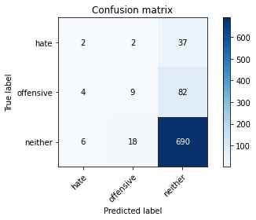

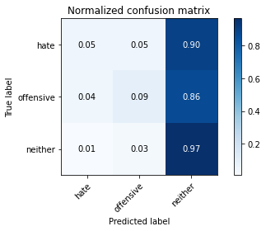

precision recall f1-score support

hate 0.17 0.05 0.08 41

offensive 0.31 0.09 0.15 95

neither 0.85 0.97 0.91 714

accuracy 0.82 850

macro avg 0.44 0.37 0.38 850

weighted avg 0.76 0.82 0.78 850

average eval_loss: 0.8534115261579647, accuracy: 0.8247058823529412

0.8247058823529412